Report for
KEEVIL PARISH COUNCIL
September 2021

WORKING GROUPS

Background
In February 2019, the Parish Council conducted a Village Survey to understand the views of residents on life in Keevil - how villagers wanted the village to look in the future in respect of the environment, conservation, housing needs, general wellbeing and other areas, and the qualities and services of most value - so that the Parish Council could consider how best to protect and enhance them, and plan ahead.
Preliminary feedback on the results was delivered at the Annual Parish Council Meeting in May 2019, at which four key themes were identified:
- Housing & development
- Parking & Traffic speed & volume
- Roads, verges & Rights of Way
- Transport & Bus
At the following meeting in July, a more detailed presentation of the results in each of these core areas was made, and villagers present were able to ask questions and sign up to working groups for these topic areas.
These were informal working groups with the broad aim of researching the relevant matters raised in the survey and reporting back to the Parish Council with any findings/recommendations. There were no terms of reference or formal minute-taking, although most groups kept informal notes. The Councillor on each group acted as facilitator and spoke about their groups activities at council meetings.
The groups as they stood in July 2019:
Housing & Develop’t | Parking & Traffic | Roads, Verges & ROW | Transport & Bus
Cllr Ginny Sherman  Fran Banfield  Sarah Dow  Kim Finch  Jim Sherman  Simon & Andrea Van Poeteren (left group December 2019) | Cllr Rosemary Banfield  Bob Ayres  Catherine Cosgrove  Malcolm Cupis  Sarah Dow  Jason Dalgliesh  Kim Finch  Julie Hammond  Nick Orton  Ann Reid  Jim Sherman (left group March 2020) | Cllr Suzanne Wickham  Fran Banfield  Malcolm Cupis  Kim Finch  Gary & Meryl Hopkins  Cara Naylor | Cllr Simon Newton  Michael Braund  Janet Hopkins  Helen Jones  Norman Owen  Geoff West  Janet White

Working Group Recommendations
HOUSING & DEVELOPMENT GROUP
The following final recommendations were made at the council meeting in March 2020:
- That the Parish Council encourage individuals to consider planting trees, shrubs, wild flowers etc. to promote wildlife conservation.
The group recommends that the Parish Council explores the planting of trees on areas on the perimeter of the airfield (map provided by the MOD).
An offer of land for a Forest School has been made to the school so it is suggested that this will enable the Parish Council to assess the resources and commitment needed for planting and maintenance.
The Parish Council should also explore the grants available for the purchase of trees.
- That the Parish Council seriously considers the creation of a Neighbourhood Plan to help decide where and what type of development should happen in our parish. The Parish Council should explore the funding available for this.
- That the Parking and Traffic working group should consider using a small area of land off Pyatts Corner/Butts Lane for parking – as identified on the MOD map*, adjacent to 37 Pyatts Corner.
*Note in minutes of January 2020 that a map had been received from MOD indicating the land they own in the parish.
The following appears as a separate item in the minutes of March 2020; it does not form part of the working group recommendations:
Rural Housing Needs Survey: The Chair recommended that Keevil should have a rural housing needs survey completed. It was agreed that the Clerk should explore the procedure involved.

PARKING & TRAFFIC GROUP
The group last met in October 2019. There were further emails and efforts were made to meet in early 2020 but the pandemic meant things were put on hold Some members have expressed a desire to continue, although it was eventually decided to wait until after the election May 2021 and allow a new council to decide next steps.
The main issues under discussion were:
- Parking difficulties especially in Martins Road and Pyatts Corner (where a number of homes have no or limited private off-road parking);
- Village gates (as speed control) - costs, research, case studies, styles...;
- Speeding, speed limits, MetroCount;
- School parking going forward (note: the school report that the morning staggered starts implemented during covid have worked well for them).
At the July and March 2020 council meetings, the following was reported:
July 2020: RB gave an update re Village Gates – will involve cost and needs to take into account opinions of local parishioners. Deferred to September meeting.
March 2020: Village Gates - Cllr. Banfield and Cllr. Sherman had met with Mark Stansby, Senior Traffic Engineer, Highways. There are suitable sites for village gates, particularly with the use of single ones. Cllr. Banfield and the Speeding & Parking Working Group will be discussing the issue and report to the Council.
NOTE: The working group has not completed any research or made any recommendations, and there was no further discussion at following council meetings.

ROADS, VERGES AND RIGHTS OF WAY GROUP
The following report was made at the council meeting in March 2020:
- Footpaths: The group initially began a walking survey of all our Parish footpaths and quickly identified areas that needed work to improve footpath signage, repair stiles, cut back vegetation, and address specific areas of danger.
The group have worked with Paul Millard, Wiltshire Council Rights of Way Officer and have made many improvements with stiles being replaced or repaired, agreement with land owners to improve the footpath and with Jeremy Cottle in Steeple Ashton, to move an electric fence, allow steps to be cut into a steep bank and also to keep vegetation cut back to keep the path safe.
The group do not anticipate any cost for Keevil Parish Council as Wiltshire Council has indicated that they will pick up the cost of materials and the work involved, possibly with the assistance of The Ramblers’ Association.
There is still work to do and members of the group are planning regular ‘working party walks’ as soon as the weather improves to check and maintain our most well used footpaths, thought the summer and autumn.
- Verges: There is a Wiltshire Council programme for ‘Verge improvement’ which is accessed via the Area Board. This may well help with places like Martins Road and parts of Main Street. This entails hard core being placed on the edge of the road surface which has been severely eroded.
Other measures could include full repair with soil and seed but with poles placed at the road edge to prevent damage while the grass takes root. This may require a contribution from Keevil Parish Council for matched funding. It is not practical to consider any of this work until the spring or summer when the weather should improve.
The group could consider a programme of education to highlight parking and driver behaviour, as there are many actions that would very quickly undo any repair work. The village magazine, website and school notices could assist to pass this message on.
The verge opposite Wisteria Cottage on Main Street was reported to Wiltshire Council in January and Jonathan Seed is taking up the case to organise an urgent repair, due to the danger that a vehicle call fall into the stream. The working party have achieved a lot of improvements; however footpaths and verges will always need attention.

TRANSPORT & BUS GROUP
The following was reported at council meetings in March this year and last year: -
March 2021: After extensive discussions, and consideration of a number of ideas, the majority of the group feels that it has met its original remit.
- Bus service: There was little the group could do to affect bus timetables, which seemed to be one of the main issues raised in the village survey.
- Minibus service: After considerable research, the group concluded the village could not afford its own mini-bus or feasibly partner with an existing service.
- Help-a-friend: At the time, there were few offers of volunteer drivers from residents, and neither did there seem to be an overwhelming need. The group intended to revisit this, including stronger promotion of the initiative, DBS checks and insurance cover.
- The village website was updated to include more links to existing services, including bus timetables, Taxi services that had offered special rates for Keevil residents, and the Trowbridge Area Community Link Scheme. https://keevilvillage.com/information/transport/
Members of the group therefore recommend that:
- There are currently no requests to be made of the Parish Council in line with its original remit, and the group should be wound up.
- A new group is formed with a remit to review accessibility concerns*, as well as monitor pertinent transport matters on an ongoing basis. Given the timing, however, this should be a matter for the incoming Council to consider after the May elections.
* A number of accessibility issues around the village have come to light in the last year, including footpaths to amenities, access to the Post Box on Martins Road, and other paths and pavements around the village presenting difficulties to mobility scooters, wheelchairs, and so on.
March 2020: There was a disappointing response to the ‘Help a friend’ pilot scheme for the drivers with only 2 more parishioners expressing interest, with a pool of 8-10 drivers, but they had no one put their hand up to say they need help. They will continue to advertise and need to confirm whether DBS checks are required and investigate insurance cover. The system will include ringing a list of the 8-10 drivers to establish availability. There will be no request to the Council.

SUMMARY OF WORKING GROUP RECOMMENDATONS
Housing & Develop’t | Parking & Traffic | Roads, Verges & ROW | Transport & Bus
Final recommendations:  - Encourage wildlife conservation by planting trees, shrubs, wild flowers;  - Consider creation of a Neighbourhood Plan;  - Revert to Parking group regarding land for parking. | No recommendations yet. Issues remain:  - Parking difficulties esp Martins Road & Pyatts Corner;  - School parking;  - Speeding, speed limits, Metrocount, village gates. | Recommendations:  - Regular ‘working party walks’ planned;  - Verge improvement measures considered;  - Education to highlight parking and driver behaviour | Final recommendations:  - Form new group to review Accessibility concerns.  - Revisit Help-a-Friend in the future, and monitor transport issues

New Developments
RIGHTS OF WAY – working with adjoining parishes
September 2020: it was noted in the minutes that a letter was sent to the Clerks of adjoining Parish Councils to propose co-operation in maintaining PROWs between parish boundaries, with (then councillor) Malcolm Cupis listed as the contact.
March 2021: The above letter had received broadly positive response, and a reply was being drafted in discussion with local farmer members.

RIGHTS OF WAY – kissing gates
June 2021: Parishioner Mrs Baker presented a petition to the council regarding the provision of kissing gates on Rights of Way through local fields (primarily on the footpath KEEV1 between lower Main Street and where it meets the byway KEEV29 at the end of Martins Lane).
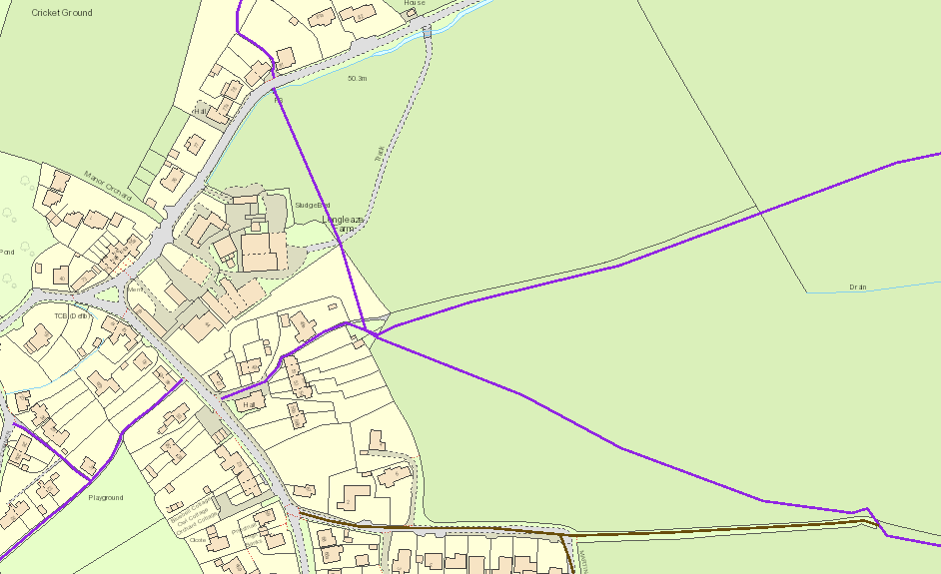
July 2021: Councillor/Chair Geoff West is setting up a new working group to which petitioner representatives and local farmers would be invited, as well as subject experts such as Paul Millard the PROW Officer for our area on Wiltshire Council.

DISCUSSION
- Only two of the groups have not concluded a final report (update: an ex-councillor said that the report made in March 2020 by the Roads Verges & ROW group should be considered final);
- There are areas of common ground between the original groups;
- One new group (Accessibility) suggested and another (ROW/Kissing gates) being set up;
- No decisions appear to have yet been taken by council on recommendations made by the groups;
How should these groups be structured and managed going forwards?

Sarah Dow, 5th September 2021

